ASSIGNMENT 23

Name : Akanksha Joshi

Roll No : B038

Batch : 3

Div : BTech CS B

-------------------------------------------------------------------------------------------------------------------------

Q.Given below is a dictionary 'customer_details' representing customer details from a Retail Application. Customer Id

is the key and Customer Name is the value.

customer_details = { 1001 : "John", 1004 : "Jill", 1005: "Joe", 1003 : "Jack" }

Write Python code to perform the operations mentioned below:

a) Print details of customers.

b) Print number of customers.

c) Print customer names in ascending order.

d) Delete the details of customer with customer id = 1005 and print updated dictionary.

e) Update the name of customer with customer id = 1003 to "Mary" and print updated dictionary.

f) Check whether details of customer with customer id = 1002 exists in the dictionary.

Code:

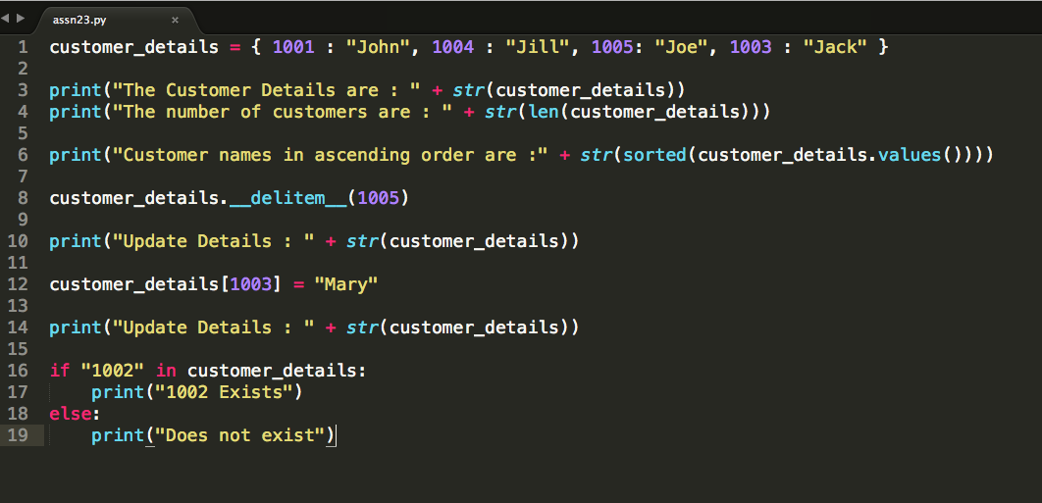

Output

The Customer Details are : {1001: 'John', 1004: 'Jill', 1005: 'Joe', 1003: 'Jack'}

The number of customers are : 4

Customer names in ascending order are :['Jack', 'Jill', 'Joe', 'John']

Update Details : {1001: 'John', 1004: 'Jill', 1003: 'Jack'}

Update Details : {1001: 'John', 1004: 'Jill', 1003: 'Mary'}

Does not exist